Document Title: X and Z of Scrap Processing
Rev Date: April 2021
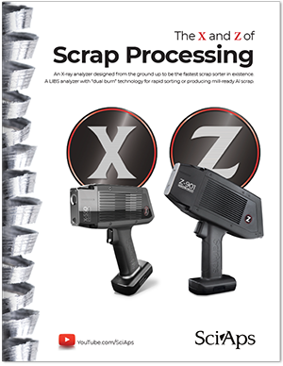
Layout Preview | English Text | Translated Text
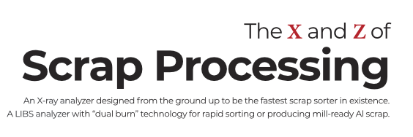 | The
 | X
 | and
 | Z
 | of
 | Scrap Processing
 | An X-ray analyzer designed from the ground up to be the fastest scrap sorter in existence. A LIBS analyzer with “dual burn” technology for rapid sorting or producing mill-ready Al scrap.
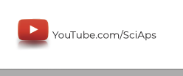 | YouTube.com/SciAps
(Page 2-3)
 | Meet the
 | X
 | Revolutionizing X-ray Gun Technology
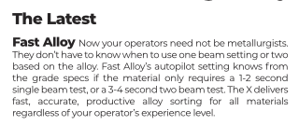 | The Latest
 | Fast Alloy
 | Now your operators need not be metallurgists. They don’t have to know when to use one beam setting or two based on the alloy. Fast Alloy’s autopilot setting knows from the grade specs if the material only requires a 1-2 second single beam test, or a 3-4 second two beam test. The X delivers fast, accurate, productive alloy sorting for all materials regardless of your operator’s experience level.
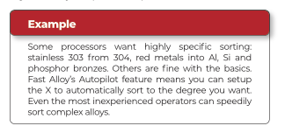 | Example
 | Some processors want highly specific sorting: stainless 303 from 304, red metals into Al, Si and phosphor bronzes. Others are fine with the basics. Fast Alloy’s Autopilot feature means you can setup the X to automatically sort to the degree you want. Even the most inexperienced operators can speedily sort complex alloys.
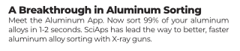 | A Breakthrough in Aluminum Sorting
 | Meet the Aluminum App. Now sort 99% of your aluminum alloys in 1-2 seconds. SciAps has lead the way to better, faster aluminum alloy sorting with X-ray guns.
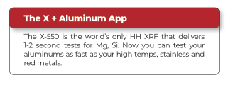 | The X + Aluminum App
 | The X-550 is the world’s only HH XRF that delivers 1-2 second tests for Mg, Si. Now you can test your aluminums as fast as your high temps, stainless and red metals.
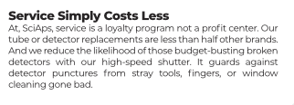 | Service Simply Costs Less
 | At, SciAps, service is a loyalty program not a profit center. Our tube or detector replacements are less than half other brands. And we reduce the likelihood of those budget-busting broken detectors with our high-speed shutter. It guards against detector punctures from stray tools, fingers, or window cleaning gone bad.
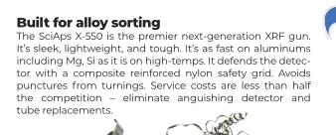 | Built for alloy sorting
 | The SciAps X-550 is the premier next-generation XRF gun. It’s sleek, lightweight, and tough. It’s as fast on aluminums including Mg, Si as it is on high-temps. It defends the detector with a composite reinforced nylon safety grid. Avoids punctures from turnings. Service costs are less than half the competition – eliminate anguishing detector and tube replacements.
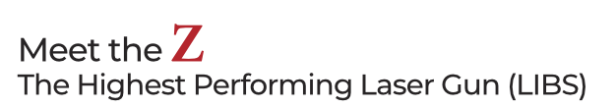 | Meet the
 | Z
 | The Highest Performing Laser Gun (LIBS)
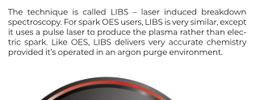 | The technique is called LIBS – laser induced breakdown spectroscopy. For spark OES users, LIBS is very similar, except it uses a pulse laser to produce the plasma rather than electric spark. Like OES, LIBS delivers very accurate chemistry provided it’s operated in an argon purge environment.
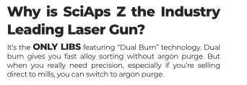 | Why is SciAps Z the Industry Leading Laser Gun?
 | It’s the
 | ONLY LIBS
 | featuring “Dual Burn” technology. Dual burn gives you fast alloy sorting without argon purge. But when you really need precision, especially if you’re selling direct to mills, you can switch to argon purge.
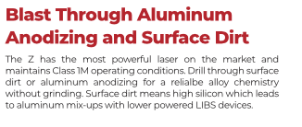 | Blast Through Aluminum Anodizing and Surface Dirt
 | The Z has the most powerful laser on the market and maintains Class 1M operating conditions. Drill through surface dirt or aluminum anodizing for a relialbe alloy chemistry without grinding. Surface dirt means high silicon which leads to aluminum mix-ups with lower powered LIBS devices.
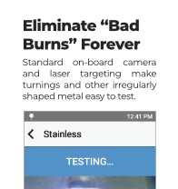 | Eliminate “Bad Burns” Forever
 | Standard on-board camera and laser targeting make turnings and other irregularly shaped metal easy to test.
(Page 4)
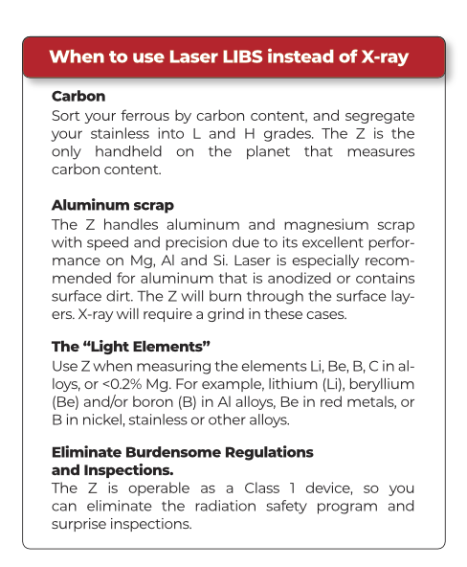 | When to use Laser LIBS instead of X-ray
 | Carbon
 | Sort your ferrous by carbon content, and segregate your stainless into L and H grades. The Z is the only handheld on the planet that measures carbon content.
 | Aluminum scrap
 | The Z handles aluminum and magnesium scrap with speed and precision due to its excellent performance on Mg, Al and Si. Laser is especially recommended for aluminum that is anodized or contains surface dirt. The Z will burn through the surface layers. X-ray will require a grind in these cases.
 | The “Light Elements”
 | Use Z when measuring the elements Li, Be, B, C in alloys, or <0.2% Mg. For example, lithium (Li), beryllium (Be) and/or boron (B) in Al alloys, Be in red metals, or B in nickel, stainless or other alloys.
 | Eliminate Burdensome Regulations and Inspections.
 | The Z is operable as a Class 1 device, so you can eliminate the radiation safety program and surprise inspections.
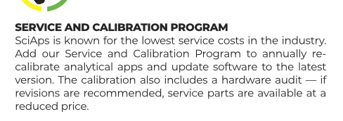 | SERVICE AND CALIBRATION PROGRAM
 | SciAps is known for the lowest service costs in the industry. Add our Service and Calibration Program to annually re-calibrate analytical apps and update software to the latest version. The calibration also includes a hardware audit — if revisions are recommended, service parts are available at a reduced price.
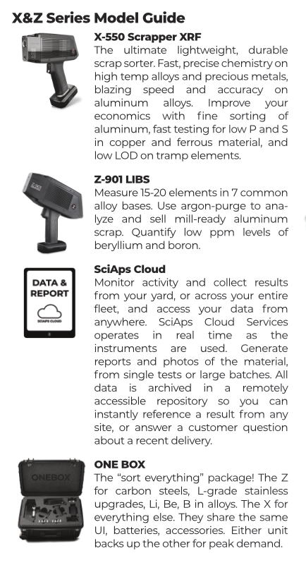 | X&Z Series Model Guide
 | X-550 Scrapper XRF
 | The ultimate lightweight, durable scrap sorter. Fast, precise chemistry on high temp alloys and precious metals, blazing speed and accuracy on aluminum alloys. Improve your economics with fine sorting of aluminum, fast testing for low P and S in copper and ferrous material, and low LOD on tramp elements.
 | Z-901 LIBS
 | Measure 15-20 elements in 7 common alloy bases. Use argon-purge to analyze and sell mill-ready aluminum scrap. Quantify low ppm levels of beryllium and boron.
 | SciAps Cloud
 | Monitor activity and collect results from your yard, or across your entire fleet, and access your data from anywhere. SciAps Cloud Services operates in real time as the instruments are used. Generate reports and photos of the material, from single tests or large batches. All data is archived in a remotely accessible repository so you can instantly reference a result from any site, or answer a customer question about a recent delivery.
 | ONE BOX
 | The “sort everything” package! The Z for carbon steels, L-grade stainless upgrades, Li, Be, B in alloys. The X for everything else. They share the same UI, batteries, accessories. Either unit backs up the other for peak demand.
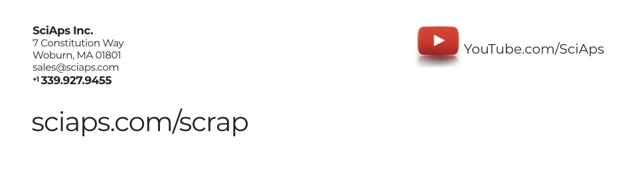 | SciAps Inc.  7 Constitution Way  Woburn, MA 01801  sales@sciaps.com
 | sciaps.com/scrap
 | YouTube.com/SciAps
If applicable, please add:
LOCAL COMPANY NAME
LOCAL WEBSITE
LOCAL PHONE

